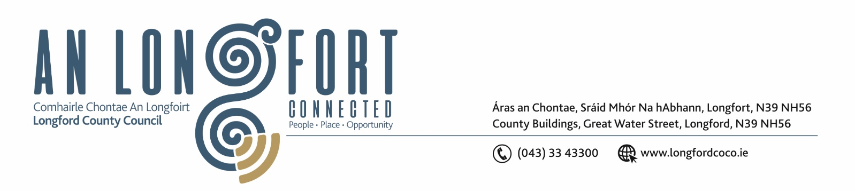

23rd September 2019.

To: Each Member of the Joint Policing Committee.

Re: Meeting of the Joint Policing Committee

Dear Member,

I wish to inform you that the next meeting of the Joint Policing Committee will take place in the Council Chamber, Aras an Chontae, Great Water Street, Longford, on Monday, 30th September 2019 at
3.00 p.m.

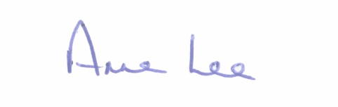
Yours sincerely,

___________________
Anne Lee,
Administrative Officer.

AGENDA

1. Confirmation of Minutes of Joint Policing Committee meeting held on the
29th July 2019 - enclosed.

2. Matters arising.

3. Declaration of Interest by Members.

5. Garda Report.

6. Local Authority Report.

7. Briefing in relation to Planning and Environmental issues.

8. Update on Longford Joint Action Plan.

9. Election of Vice - Chairperson of Joint Policing Committee.

10. Arrangements for 2019 JPC Public Meeting.

11. Date of next meeting.

